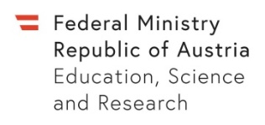 | Reimbursement for material costs  (Project leaders only)  WISSENSCHAFTLICH-TECHNISCHE ZUSAMMENARBEIT (WTZ)  SCIENTIFIC & TECHNOLOGICAL COOPERATION |  | 
Cooperation country:
Project number in Austria:
Project leader’s name:
Project leader’s date of birth:
Research institution in Austria:
Address:
E-mail:
I request a one-time payment for material costs of max. EUR 2,000.— as applied for in my application*. |  | Yes
BANK DETAILS
Name of the bank:
BIC:
IBAN:
Name of account holder:
internal assignment number (university project accounts only):
Purpose (if required):

PLEASE NOTE:
Reimbursement for material costs is only made, if applied for in your application. Please be aware that all beneficiaries are responsible for possible tax payments themselves.
___________________________________________________
Place, date and signature of the applicant
PLEASE DO NOT FILL IN!
Material costs: | EUR |  | Budget:
 |  |  | WTZ Statistics:
 |  |  | StipOnline:
Total: | EUR |  | The calculations have been checked for accuracy:  (OeAD-GmbH)
PLEASE SUBMIT THIS FORM AND THE INVOICES TO:
OeAD
International Cooperation in Higher Education
Programm WTZ, Ebendorferstraße 7, 1010 Wien
wtz@oead.at
* In Austria up to EUR 2,000.- per project of the granted funding may be applied for project-related material costs. Only project-specific material costs may be requested, that are essential to carry out the research project and that go beyond the resources made available from the research institution’s infrastructure. Infrastructure or basic equipment of research institutions cannot be funded.
Version: 20221110

