Mid-term Scientific Report

KoEF Research Cooperation Project

Project Overview
Project Title
Acronym
Cooperating Countries
Coordinating Institution
Project Coordinator
(including academic title)
Email Coordinator
All involved Austrian institutions
All involved partner institutions of the Global South
Project Start
Reporting Period
Total Budget acc. to Grant Agreement (€)
No. of Mobilities in Reporting Period  (per person) | PhD student Female | PhD student Male | PostDoc Female |  | PostDoc  Male | Total
Incoming
(to Austria)
Outgoing
(to the Global South)
Field research
(within the Global South)
Branch(es) of Science  (max. 3) | Branch Name |  |  | Six-Digit Code
Contribution to SDGs  (max. 3) | Name of SDG |  |  | SDG Number

Content

Project Overview 1
1. Narrative summary of the project activities 3
2. Complete list of funded mobilities (research stays) 3
3. Achievements and envisaged results 3
4. Contribution to the SDGs, implementation of gender and diversity issues 3
5. Reflection on the partnership and cooperation 3
6. Changes in project environment, challenges and mitigating measures 4

Funded by:

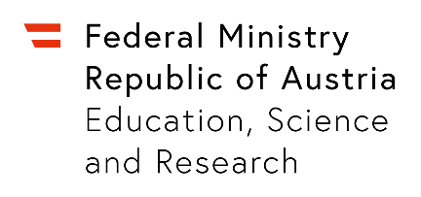

Narrative summary of the project activities

Complete list of funded mobilities (research stays)
Name | PhD scholar or PostDoc | Date | From-to | Activities conducted

Achievements and envisaged results

Contribution to the SDGs, implementation of gender and diversity issues

Reflection on the partnership and cooperation

Changes in project environment, challenges and mitigating measures

http://www.statistik.at/kdb/downloads/pdf/OEFOS2012_EN_CTI_20190903_162012.pdf
https://sdgs.un.org/goals

